Pedigree: Blue from Black Boy Country

Blue  from  Black Boy Country  28.04.2004  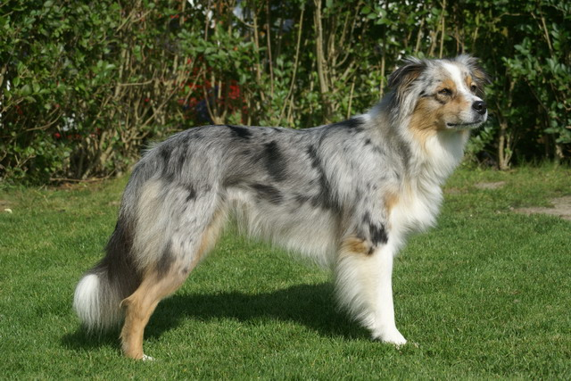     | Some Kind of Magic  Yust Ah-some  07.06.1999   | Snowcrest Luck  of the Draw  13.10.1997   | Ch. Moonlight`s Rollover Beethoven  05.03.1992  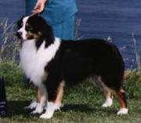
Montana`s Blue Ravinon Q
17.12.1993

 |  | Wyndanwood Canadian Sunset  08.06.1997  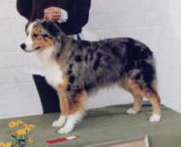 | Ch. Suejacks Copper Top  10.06.1994  
Briergreens Bright of Triblue
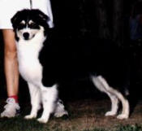
 | Pinoccia  du Coral Twivro  20.08.1999 /  09.09.2009   | Twist of Kobhorn Ranch  02.06.1992 / 17.12.2004  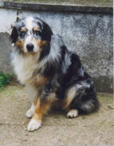 | Legacy`s Dusty Snow  Blue-merle  04.12.1989
Swanee of Black Wood
Blue-merle
30.09.1987
 |  | Nanda Devi  Red Girl  05.04.1997  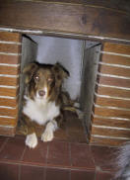 | Jocker  
Stardusts Calaxie


